Survey result: meaning of the word “inclusion”
The aim of this survey is to evaluate the students opinions and beliefs on the inclusion theme within the school environment. To assess the attitudes of the students we gave questions that provided a synthesis of knowledge on the general meaning of inclusive education deriving from the experience of the main school stakeholders. Here the tables with the graphs showing the answers given by the students, their percentages. The students who answered attend secondary school and come from 5 different Countries, the answers given are related to their perceptions, their commitment and participation in school life.
- Which answer best describes the term inclusion?
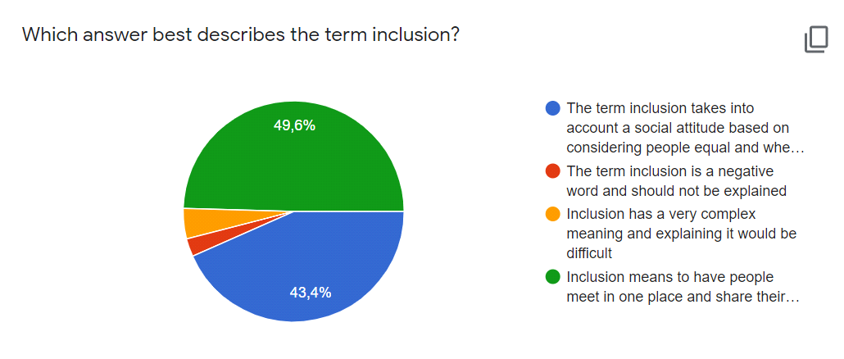

1.Pie-graph : the graph grouped in table 1, shows the percentages of the two chosen options that best represent the meaning given to the word of inclusion: the green slice represents 49,6% for the fourth option. The blue slice, a good 43,4% percentage refers to the 1st option. There is only a 5,5% difference between these two options.
______________________________

- What are the aims of inclusion?

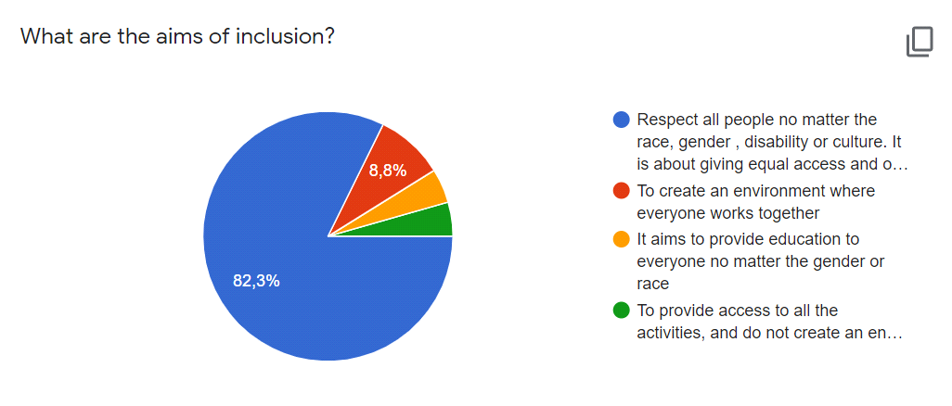

2. Pie-graph : the graph grouped in table 2 shows the percentages relating to the main purpose of the inclusion and the blue slice offers 82,3% referring to the 1st option.
__________________________

- What are the features of inclusion?
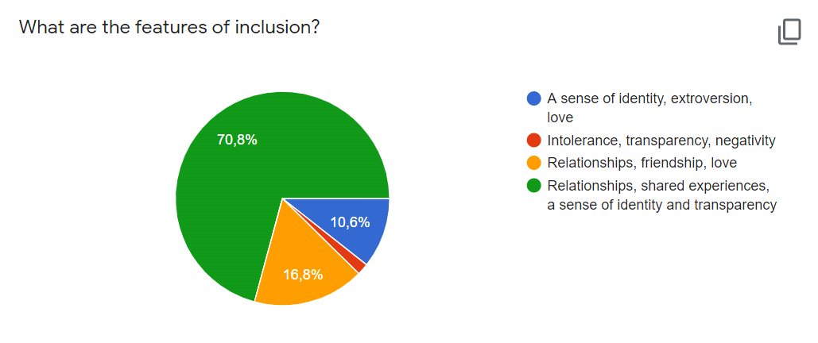
3.Pie-graph : the graph grouped in table 3 displays the students perceptions regarding the main features of inclusion: the green slice has 70,8%: sense of identity; but also friendship with 16,8%
_______________________________

- What is the greatest obstacle in inclusion?
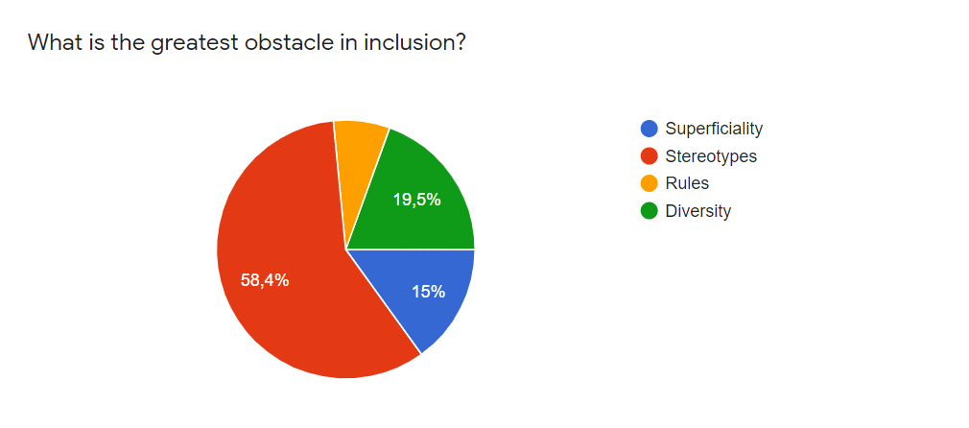
4. Pie-graph: the graph grouped in table 4 displays the greatest obstacle in inclusion: stereotypes the red slice with 58,4%; the diversity the green slice with 19,5% and the blue one, the superficiality, with 15%
__________________________________

- Which one is an example of inclusion?
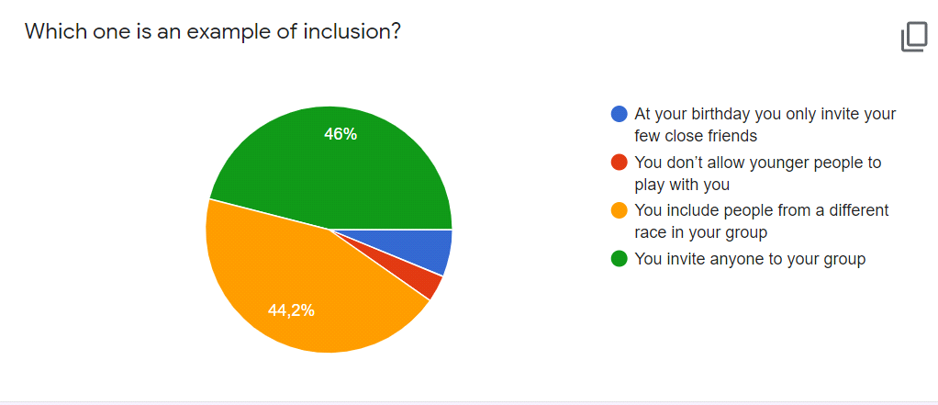
5. Pie-graph: the graph grouped in table 5 represents the 2 best examples of inclusion: the green slice with 46% and the yellow one with 44,2%
_______________________________

- What are the qualities of an inclusive leader?
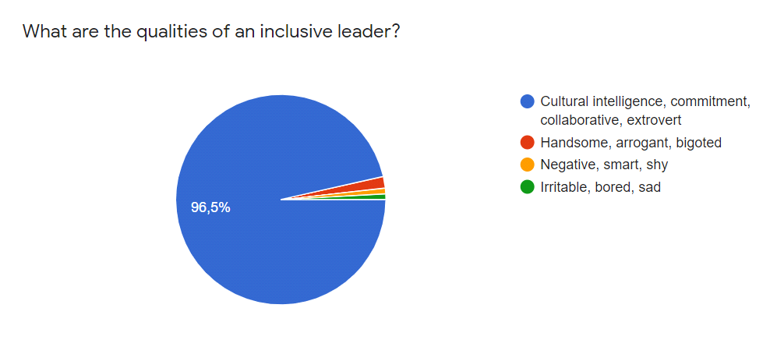
6. Pie-graph: the graph grouped in table 6 concerns the qualities to be an inclusive leader: intelligence, commitment, collaborative represented by the blue slice with 96,5%
____________________________

- What an inclusive school is like?
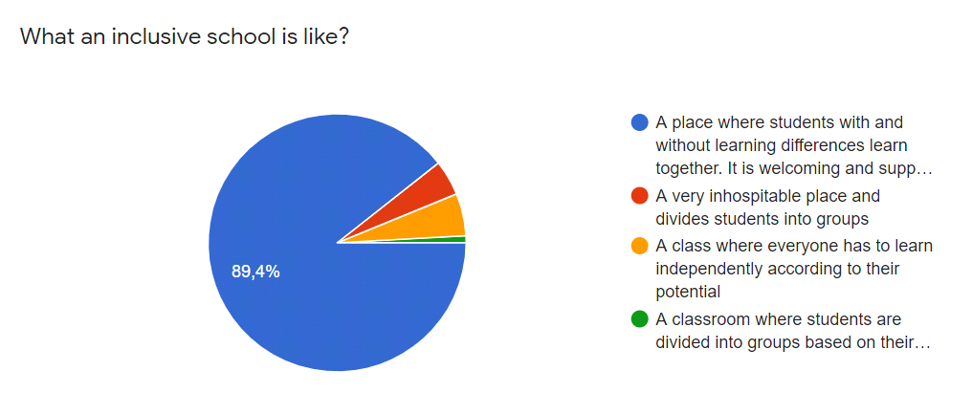
7. Pie-graph: the graph grouped in table 7 shows the description of how an inclusive school should be, the students chose the first option: blue slice with 89,4%
___________________________________

- What are the components of inclusion in education?
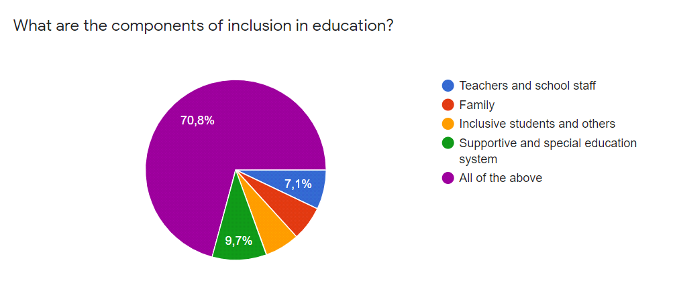
8. Pie-graph: the graph grouped in table 8 considers all the components of inclusion in education, with 70,8% the purple slice prevails
_______________________________

- How does your school promote inclusion?
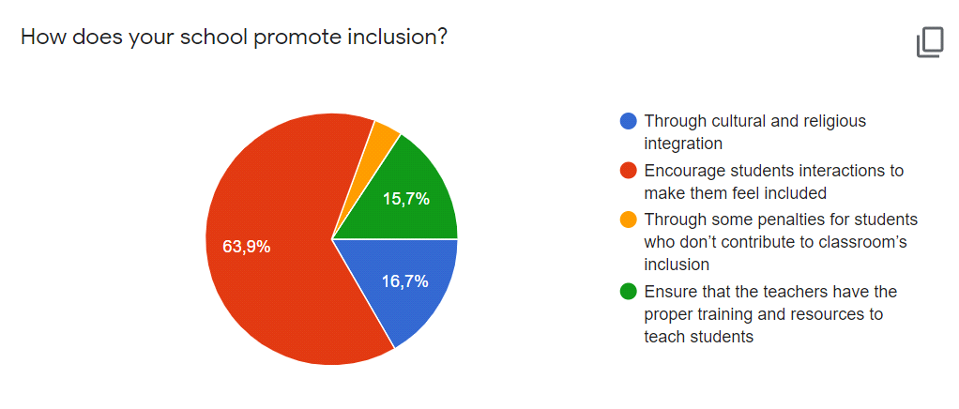
9. Pie-graph: the graph grouped in table 9 shows how our Erasmus partners promote inclusion in school: the best percentage with the red slice is 63,9%, many students feel themselves included; then blue and green slice with a percentage of 16,7% and 15,7%.
__________________________________

- How does your school overcome cultural barriers in the classroom?
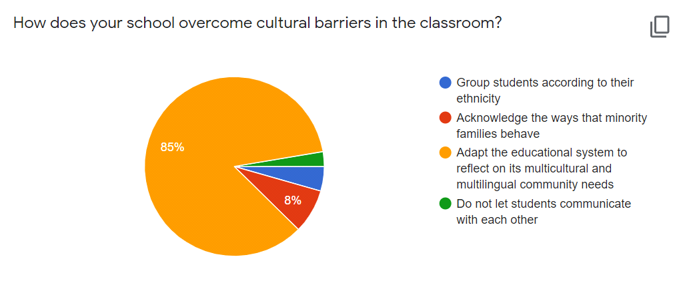
10. Pie-graph: the graph grouped in table 10 considers how school partners overcome cultural barriers in the classroom; yellow slice with 85% of students answers say that their schools take into consideration the needs of the community.
________________________________

- How can your school implement or improve inclusion?
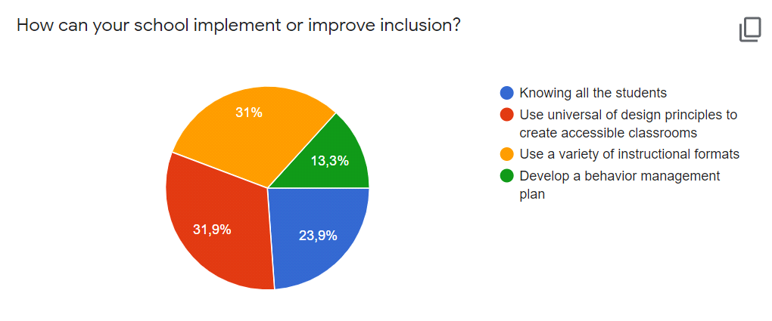
- Pie-graph: the graph grouped in table 11 shows how the school can improve inclusion: 31% - yellow slice - the school can improve inclusion thanks to a variety of educational formats or 31,9 % - red slice - for accessible classrooms;
__________________________________

- What would you like to have as inclusive practices in your school?
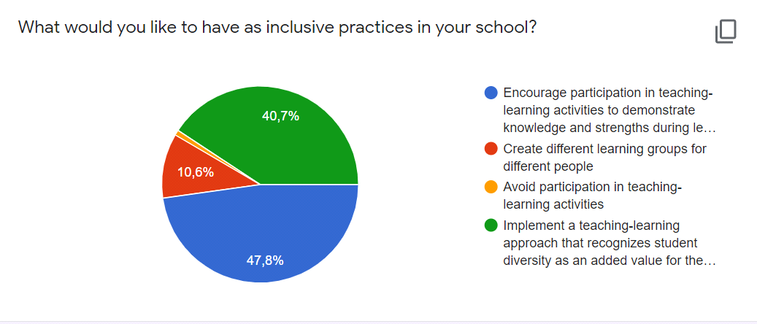
12. Pie-graph: the graph grouped in table 12 explains which inclusive practices students perceive best to be implemented in their school: 47,8% - blue slice - encouraging student participation during the lesson; 40,7% - the green slice refers to the importance of diversity as a value for the whole class
____________________________________

The findings show a general positive attitude towards “inclusion” and suggest that inclusive education heightens the awareness of each interrelated aspect of the school as a community, challenges stereotypes, and promotes contextually relevant practices. The questionnaire answers conclude with a series of possible future directions, given by the students in the last open question, for research and a critical reflection, that is needed to help teachers achieve progress towards a complete and significant student inclusion in the school and in the community:
Students opinions and suggestions:
Open question: From your point of view does Erasmus + project improve inclusion for students and teachers too?
- We would like to clarify that inclusion automatically refers to everyone despite sexuality, gender identity, ethnicity, religion, culture and disabilities.
- Yes ,I think with this project everyone will be able do, develop a sense of inclusion and hopefully certain people who still believe in stereotypes will stop and even make new friends.
- Absolutely, Erasmus+ project is a great opportunity for everyone and it will improve our inclusive skills and develop our empathy
- Yes, it does because Erasmus project has always been a meeting and sharing point for different cultures and communities.
- In my opinion Erasmus helps to improve inclusion for students and teachers, it allows us to work together, share experiences with students and teachers from other countries and get to know each other.
- Yes, because in this project, in addition to being guys from many countries and cultures, there are also teachers. So how we do friends, teachers can do the same too.
- Yes, Erasmus + project improve inclusion for students and teachers because we learn how to accept our differences and appreciate our diversities.
- The project in itself can help but we have to take into consideration the way some cultures and countries are. We can improve the mindset of younger generations but the deep-rooted hatred that the older generations were taught can not be changed as easily. If someone doesn't want to get over their prejudices they will not and we can't force them to. I also think the project should include LGBT+ people as one of the oppressed groups because I know a lot of people that would like to dress more feminine/masculine but are afraid of the prejudice.
- From my point of view, yes, because it creates many activities that include teachers and students no matter where they are in activities, it makes them collaboratives and it creates connections and friends.
- I think so that project is very important and special, because is an opportunity to stay in contact with other peoples from other countries and that is very important for the integration of students and teachers, to learn the various countries traditions and cultures.

